Southern Tier Chapter of
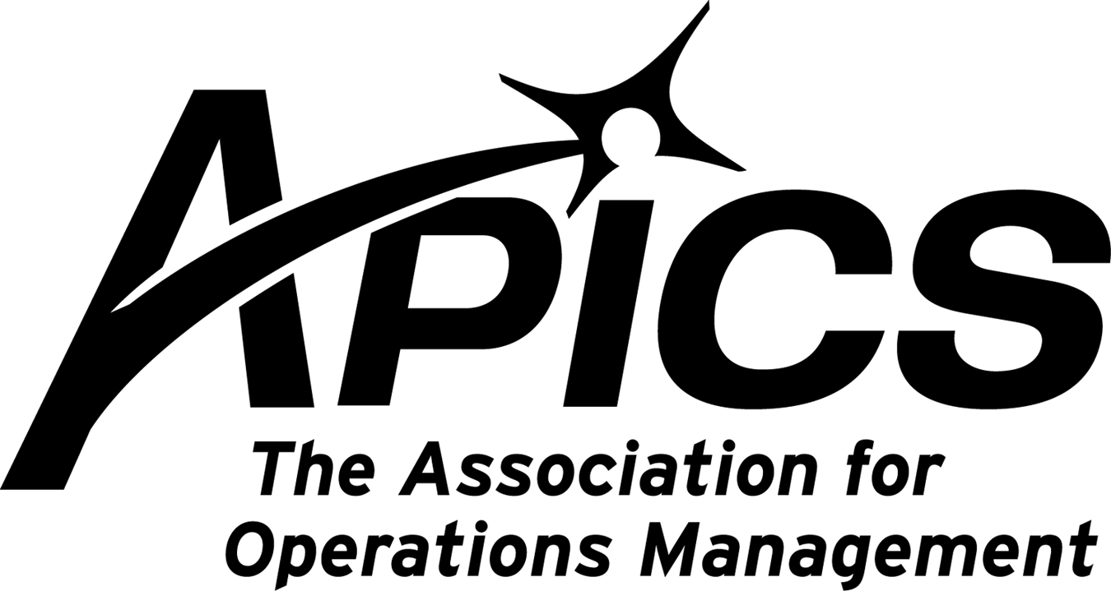

“Advancing productivity and innovation and competitive success.”

MARCH DINNER MEETING

“Common Mistakes Investors Make”

Southern Tier APICS will be joining IEEE and Gold Afinity this month for an informative presentation on a topic of interest to all today. Economic theory assumes people will work to maximize their income. However, behavior often contradicts this theory.

“Why do so many otherwise sensible people make foolish financial choices? Why do so many investors sell great stocks just before they skyrocket or cling tenaciously to lousy ones until they plummet? Why do some Americans overpay when they buy a house while others reap too little when they sell their home? And why are so many shoppers willing to spend more for a product bought on credit than with cash? Indeed, whether in the stock market or in the supermarket, most of us keep making financial faux pas that cost us thousands of dollars every year.”
- Gary Belsky and Thomas Gilovich, Why Smart People Make Big Money Mistakes

Fortunately, many of the most common and costly money blunders we make can be explained – and corrected – by the new science of “behavioral economics.”

This talk describes the paradoxes of how “people spend, invest, save, borrow and most important, waste money”, and why their approaches to these activities are often counterproductive. You will learn behavioral tips to enable you to enjoy greater financial freedom.

Date: March 16, 2010

Location: On Target Technology. Directions: http://www.ontargettechnology.com/files/OTTDVisitorGuide09.pdf

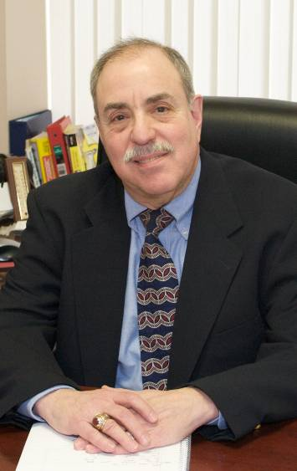
Endicott, NY (607) 755-4990
Hosts: The Binghamton Section of IEEE (www.ieee.org/binghamton) and GOLD affinity
group.

Agenda:
5:30 PM – Networking
6:00 PM – Dinner
6:30 PM – Presentation and Discussion
Deli sandwiches, snacks and drinks will be served.

Cost: IEEE Members: $10; Non-members: $15.

RSVP via email to Socci@ieee.org and pay at the door.

Speaker: Harold Sasnowitz, Financial Planner, Professional Asset Strategies, LLC
Harold Sasnowitz received the BEE degree from Cornell University, an MS in Computer Systems from Binghamton University, and an MBA from the University of Phoenix. He’s a Senior Member of IEEE, and was actively involved in the Binghamton Section, serving as the Section Chairman for three years, the Area Chairman for six years, the Region Vice Chair for two years, on the Region 1 Awards committee for seven years, and the Region Bylaws Chairman for 3 years. He retired from Lockheed Martin in December 2006 after working in Owego as an engineer and program manager.
A year before retirement he started preparing for his second career as a financial planner by taking a series of courses approved by the Certified Financial Planner Board of Standards, through the College for Financial Planning Professional Education program. He successfully completed that program in early 2007, and passed the Certified Financial Planner exam in July. Harold opened the Binghamton office of Professional Asset Strategies in downtown Binghamton, in 2007. Professional Asset Strategies is a Registered Investment Advisory firm providing fee-only investment management and financial planning services.

Update from the VP of Education
Donald Sheldon, CFPIM, CIRM, CSCP

Associate, Lead, Master Instructor Status


It is a real treat to write an educational update for this newsletter. Two of our members have been chosen to be recognized within the APICS instructors group at an elevated level.

Patrick Rogan has been designated as an Associate, CPIM instructor.

David Gardner has been designated as a Master CPIM instructor (highest level).
These are new designations with special requirements required for the various levels of recognition. We are fortunate to have this instructional talent within our ranks. Congratulations to both Patrick and David for their accomplishment and for their dedication and contributions to our local chapter. We are proud to have them in the Southern Tier chapter of APICS!

CSCP
Additionally, I am still interested in receiving interested names for the CSCP certification education. I presently only have a couple people interested. We will need at least 5 or so to run the class.

CPIM
Dave Gardner is starting a MPR course at BCC on Tuesday evenings. If you are interested it is not too late to join his class.

Educational Opportunities!!!

UNH May 21 Conference on Life Cycle Assessment
The University of New Hampshire, will sponsor a one-day conference titled: "Competing in the Green Marketplace: Life Cycle Assessment--What It Is, Why It's Important, and How to Do It." It will be held on Friday, May 21, at the Sheraton Harborside Hotel in Portsmouth, NH, from 9 a.m.-4 p.m.
Internationally prominent Life Cycle Assessment experts, Gregory Norris, Catherine Benoit, and Kevin Gardner will present sessions on:
(1) Sustainability and its Relationship to Life Cycle Thinking
(2) How to use LCA and Environmental Analysis to Gain Competitive Advantage
(3) How to use LCA to Analyze the Social Impacts of Your Business
(4) a Demonstration of new Earthster LCA software and Next Steps to Supply Chain Engagement.
Nancy Hirshberg, VP of Natural Resources from Stonyfield Farm, will be Guest Luncheon Speaker and discuss "Lessons from the Trenches: Using Life Cycle Thinking to Minimize Environmental Impact and Maximize Profits."

The conference is cosponsored by UNH Professional Development & Training and the UNH Environmental Research Group. Cost is $270 ($295 if registered after May.
For complete information including registration instructions, reference the attached or go to: http://www.learn.unh.edu/greenmarket.

Unemployed Membership Extension Program
If you are an unemployed APICS member whose membership is coming up for renewal and you are actively seeking work within the production and inventory management field, you may apply for an extension of membership benefits through the Unemployed Membership Extension Program. This program enables members seeking employment within the production and inventory management industry to
extend their membership for six months free of charge*. If you meet this criterion and are interested in applying for an extension of membership benefits due to unemployment, download an application or contact APICS Customer Support.

*Note: Members may apply for this extension up to three times for coverage over an 18 month period. Members apply for the extension through their local chapter, which must approve the request and waive chapter dues. Members approved for this waiver will receive electronic membership for the duration of the waiver, which entitles you to electronic communication of all member benefit materials.

Go to url http://www.apics.org/Membership/Join/unemployed.htm

Your 2009-2010 Board of Directors

President Dave Gardner dgardner@akraturn.com
Education Director Don Sheldon dsheldon@sheldoninc.com
Secretary Deb Unkel deb.unkel@raymondcorp.com
VP Membership Lee Schechter lschechter@stny.rr.com
VP Programs Michael LoSapio Michael.losapio@synergyresources.net
Executive VP /Director of Finance Steve Whited sjw6@meadwestvaco.com
Web site Michael LoSapio
Publicity / Marketing Kelly Noreika Kelly.noreika@lmco.com

Southern Tier APICS
PO Box 1107
Binghamton NY 13902-1107

